

Corinne Thépaut-Cabasset ICOM Costume Chair,
20th July 2021,

Dear ICOM Costume Friends and Members,

Hope this letter finds you all safe and well.

ICOM Costume is still working under pandemic covid-19; as a consequence the Committee will hold online the General Assembly and Annual Meeting 2021.

After much consideration and after the consultation of ICOM Costume members the Versailles conference is cancelled because of the global sanitary crisis due to covid-19.
Maybe we can make it happen another year or we could consider having a study trip at Versailles for the Committee later on?

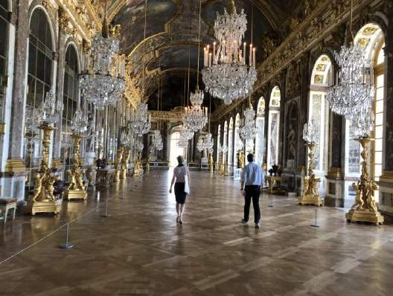
Corinne in the Hall of Mirror July 2019©Copyright reserved

For 2021, ICOM Costume General Assembly and Annual Meeting will go online 30-31 August.

Please save the date in anticipation of receiving the links for registration and the full programme of the digital activities.

During the meeting we’ll have a glimpse of ‘The Making of Luxury’ with presentations and short videos behind the scenes.

ICOM Costume youtube channel will be launched for the Annual Meeting 2021.

Two digital guided tours organized and recorded for the Costume committee will be available online upon registration.

The committee is also calling for your news to be shared in an open forum online on 30 August. Please send your proposal to the chair of the committee by 15 August: corinne.thepaut-cabasset@chateauversailles.fr

The committee needs your active participation to this event. This is important for all members to be able to share news, books and publications, exhibitions… especially at a time where are still distant from each other…

Please check the news page and the meeting page on ICOM Costume mini site: http://costume.mini.icom.museum
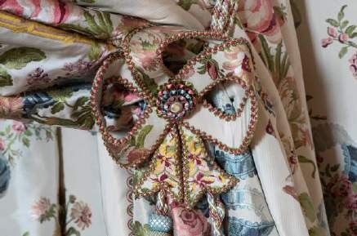
Photo©Thomas Garnier/Château de Versailles

Next year will be ICOM triennial in Prague. The call for the 2022 ICOM Costume meeting will be announced on the theme: ‘The Ritual Power of Clothing’.

ICOM Costume committee conference 2022 will be hosted at the museum of Decorative Arts in Prague. I am very grateful to our colleagues in the Czech Republic.

Stay tuned.
Looking forward to e-meeting you in August!

Kindly yours,

Corinne Thépaut-Cabasset
Chair of the international Committee ICOM for museums and collections of Costume Email: corinne.thepaut-cabasset@chateauversailles.fr

