

Corinne Thépaut-Cabasset ICOM Costume Chair,
5th March 2021,

Dear ICOM Costume Friends and Members,

I hope you are all well. Good news, African Fashion is explored by museums in Europe.

“Black people are the Curators of Cool, you often hear. But that is by no means always acknowledged or recognized. That has everything to do with power and history.” The Centraal Museum in Utrecht (The Netherlands) is opening from 3 March to 24 May 2021 a new exhibition Voices of Fashion, Black Couture, Beauty and Styles. Along with the exhibition, the Centraal Museum publishes a book in collaboration with Serena Angelista and Glamcult.
More information about the exhibition at: https://www.centraalmuseum.nl/en/exhibitions/voices-of-fashion

Voices of Fashion Centraal Museum Utrecht (NL)@Moncler x LemLem

The V&A in London (UK) announces Africa Fashion exhibition with a public call-out to uncover iconic designs. Opening June 2022, the exhibition will celebrate the vitality and innovation of this vibrant scene, as dynamic and varied as the African continent itself.

The public call-out seeks to uncover personal testimonies from those who have worn their beloved garments. Items the V&A are seeking for the exhibition include:
- Rare and early designs by Shade Thomas-Fahm, Chris Seydou, Kofi Ansah and Alphadi
- 1980s experimental garments in bògòlanfini by Chris Seydou

- Twentieth century kente, bògòlanfini, khanga and commemorative cloths from the independence and liberation years that connect to personal stories
- Family portraits and home movies form the independence and liberation years showing African and African diasporic fashion trends of the day
- Made-to-order garments, including aso ebi, co-created by local tailors, dressmakers and their clients, worn at festivals or to mark significant personal milestones, from 2010 onwards
- Copies of the Drum Magazine from 1950-1970

Members of the public with objects that fit the above description are asked to get in touch by email at africafashion@vam.ac.uk, and to share their pictures and memories on social media using the hastag#AfricaFashion

More information can be found here:
https://vanda-production-assets.s3.amazonaws.com/2021/01/20/10/29/41/720a97ac-ef5f- 4020-b42c-12e194ad3130/VA_Africa_Fashion_Callout_PressRelease.pdf
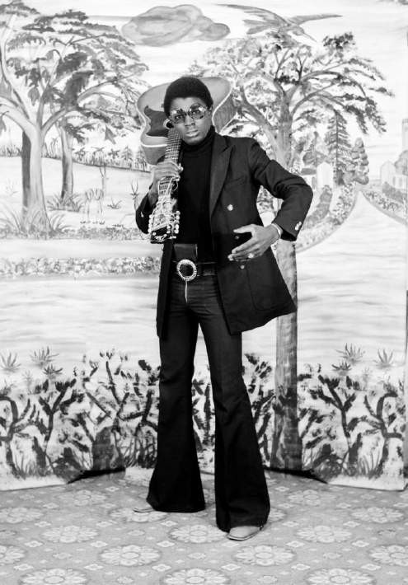
Untitled by Hamidou Maiga, 1973. V&A E.305-2012. Gift of Jack Bell Gallery London. Copyright of the artist, courtesy of Jack Bell Gallery

Stay tuned as news are updated on http://costume.mini.icom.museum/news/
And do not forget to follow Costume committee on LinkedIn, Instagram, Twitter and Facebook.

Kindly yours,
Corinne Thépaut-Cabasset
Chair of the international Committee ICOM for museums and collections of Costume Email: corinne.thepaut-cabasset@chateauversailles.fr

